**MENTORH3R 3.0**

**CASE STUDY PROJECT**

**GROUP 12**

**PROBLEM STATEMENT**

**BACKGROUND**

Kevin the HR manager of a growing company is feeling alarmed and overwhelmed by high employee turnover rates. This issue is negatively affecting team performance and overall morale, causing additional strain on remaining employees and hindering company growth.

Kevin is anxious about addressing the underlying reasons for turnover and is under pressure to develop effective strategies to improve employee retention

**TASKS**

1. Examine the reason behind the high employee turnover Kevin is facing.

2. Propose a detailed action plan to improve employee retention and address underlying issues

3. Consider the potential outcomes of your proposed plan



**About the Data used**

Our dataset is gotten from Kaggle https://www.kaggle.com/datasets/marikastewart/employee-turnover?resource=download and is from a large US company (no name given for privacy reasons).

The HR department has assembled data on almost 10,000 employees who left the company between 2016-2020. They used information from exit interviews, performance reviews, and employee records.

**Data Dictionary**

**Department-** the department the employee belongs to.

**Promoted-** 1 if the employee was promoted in the previous 24 months, 0 otherwise.

**Review-** the composite score the employee received in their last evaluation.

**Projects-** how many projects the employee is involved in.

**Salary-** for confidentiality reasons, salary comes in three tiers: low, medium, high.

**Tenure-** how many years the employee has been at the company.

**Satisfaction-** a measure of employee satisfaction from surveys.

**Bonus-** 1 if the employee received a bonus in the previous 24 months, 0 otherwise.

**Avg_hrs_month**- the average hours the employee worked in a month.

**Left-** "yes" if the employee ended up leaving, "no" otherwise.

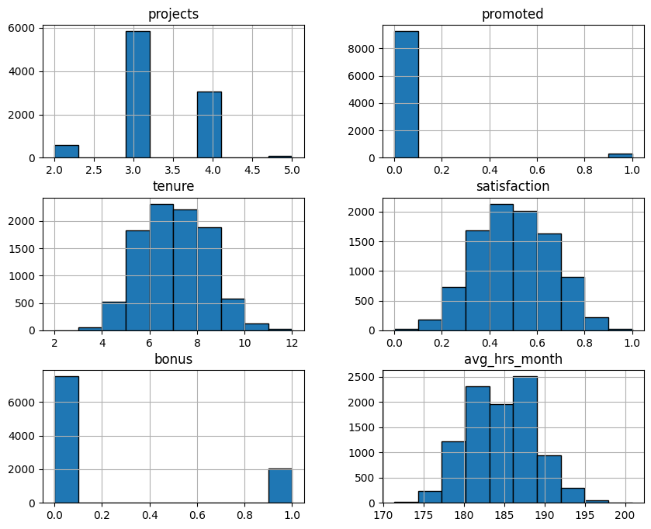

1. Projects: Most individuals have worked on 3 or 4 projects. Fewer individuals have worked on 2 or 5 projects.

2. Promoted: The vast majority of individuals have not been promoted (value 0), with a small number having been promoted (value 1).

3. Tenure: The distribution of the number of years an individual has been with the company is roughly normal, with most individuals having a tenure of about 5 to 8 years. Fewer individuals have very short or very long tenures.

4. Satisfaction: The distribution is approximately normal, with a peak around a satisfaction level of 0.5. This indicates most individuals have a moderate level of satisfaction.

5. Bonus: individuals did not receive a bonus (value 0), while a smaller group did (value 1).

6. Avg_Hrs_Month: The distribution is roughly normal, centered around 185 to 190 hours per month. This suggests that most individuals work around this range of hours.

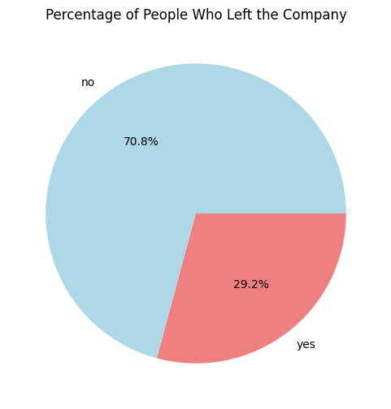

With **NO** being employees who stayed and **YES** being employees who left we see that 29.2% of the workforce left.

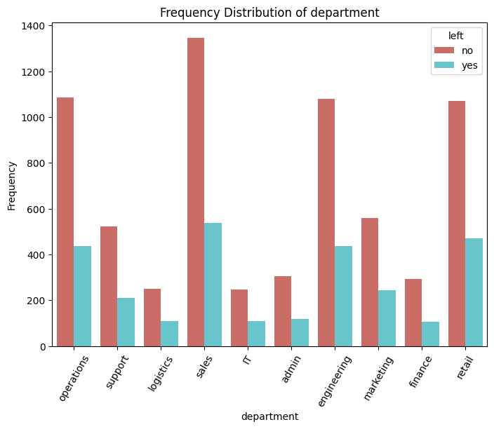

**Departments:**

Sales, operations, and retail are the largest departments, and although more employees stayed in these departments, the number who left is still notable.

Logistics and support departments have higher proportions of employees leaving. These departments might benefit from a review of working conditions or incentives to reduce turnover.

Conclusion: The company might consider department-specific strategies to reduce attrition, especially focusing on large departments like sales, operations, and retail, where the absolute number of employees leaving is higher.

For departments like logistics and support, where the attrition rate seems higher relative to the size of the department, it might be essential to investigate the underlying causes of employee dissatisfaction or other factors leading to turnover.

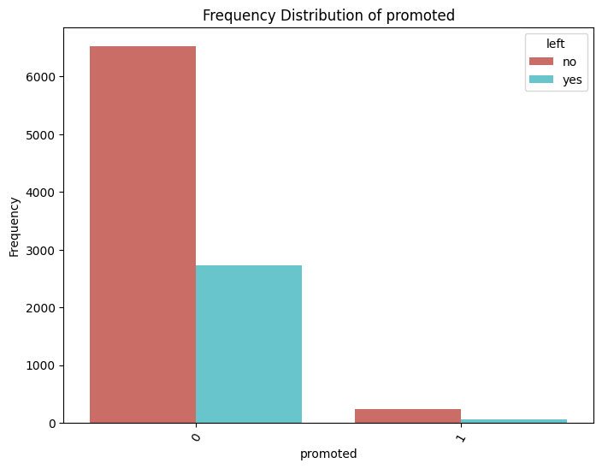

Promoted

The data shows that the company rarely promotes employees as the percentage of employees who were not promoted cover 97% of the total workforce with a 3% minority being promoted.

Conclusion: employees may feel undervalued and are choosing to leave as there is the absolute number of employees leaving fall under those who haven't been promoted.

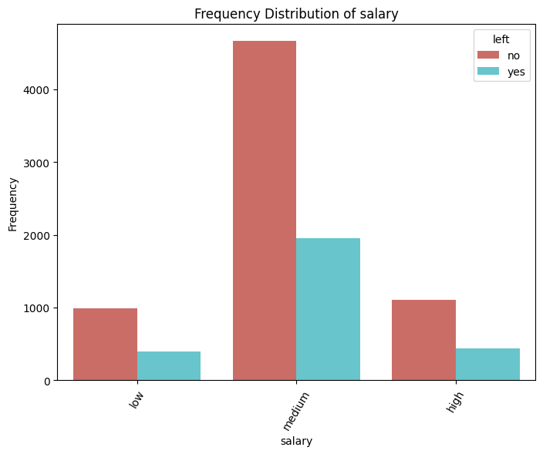

**Salary:**

Employees with low or medium salaries are more likely to leave the company than those with high salaries.

This suggests a possible correlation between salary level and employee retention, where higher salaries might contribute to lower attrition rates.

Employee Distribution: The majority of the workforce is in the medium salary category. This makes it crucial for the company to focus on retention strategies for this group.

Conclusion: To reduce attrition, the company might consider increasing salaries or providing additional benefits, especially for those in the lower and medium salary brackets, as these groups show higher rates of leaving. Additionally, further analysis could be done to understand other factors contributing to employee attrition.

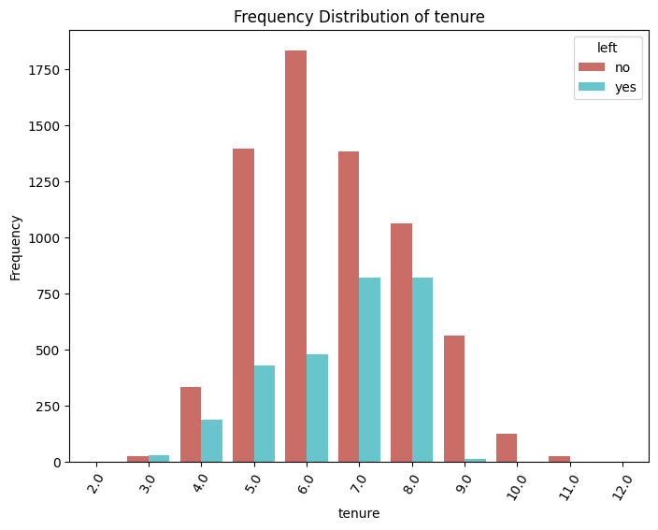

**Tenure**

The employees who have been with the company between 5-8years make up a majority of the workforce and we see the rise in employee's leaving in that characterictic as against the others who are new in the company or who have stayed longer than 8years.

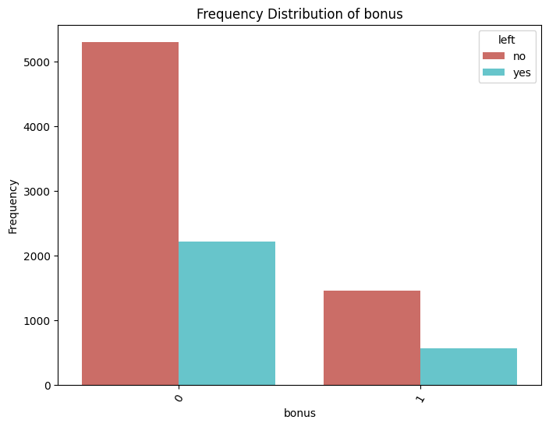

**Bonus**

Employees who do not receive bonuses have a higher tendency to leave than those who do. While there is a notable number of those that stay, we can also see the rise in those who leave

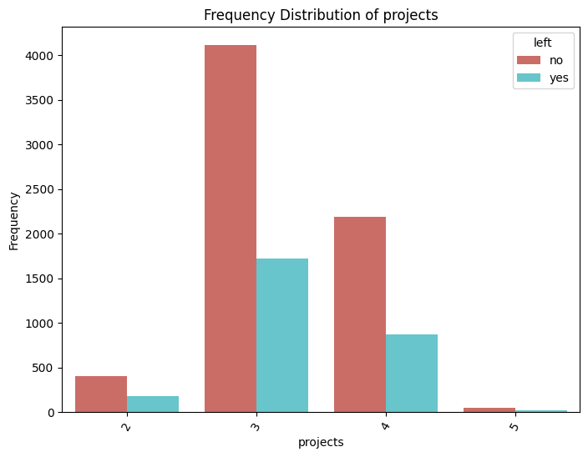

**Projects**There is a significant number of employees who take on 3-4 projects. These also contribute vastly to the number of employees leaving, compared to those who take on 2 and 5 projects.